კონტროლერი

ძირითადი მოთხოვნა:
- საკომუნიკაცია პორტი: Wi-Fi
- ინტეგრაციის საშუალება: API, SDK

მწარმოებელი: huidu

მოდელი: Single-dual Color Controller HD-W63
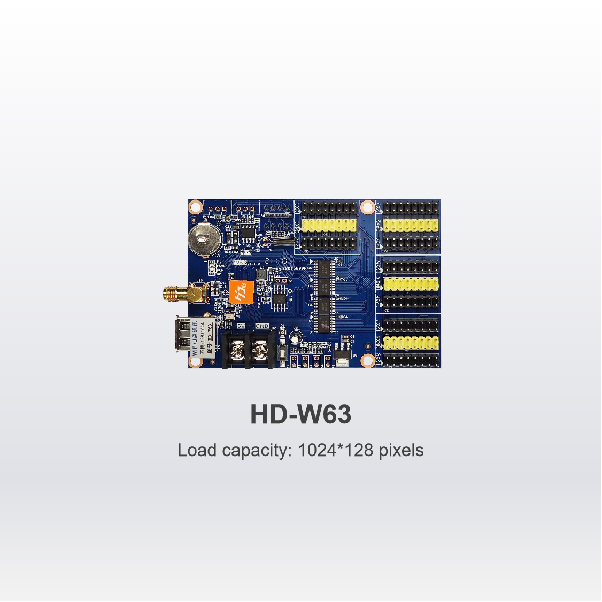

Contents | Parameters
Support module | Single Color/ Dual Color /Tricolor conventional scanning methods
Control range | Single color: 1024*128  Dual color: 512*128
FLASH Capacity | 4M Byte
Communication Port | U-Disk、Wi-Fi
Support Colorful | Full-color module can display red, green, blue, yellow, purple, green, white
Program Quantity | Max 1000pcs Programs. Can play by time section or control by buttons.
Area Quantity | 20 areas with separate zone, and separated special effects and border
Display Showing | Text、Picture、3DText、Animation（SWF）、Excel、Timing、Temperatures（humidity）、Count、Lunar calendar
Display | Sequence display, button switch, remote control
Display effect | 1、Text、Picture, Time, Timing 、Temperature or temperature and humidity (external module required) Display  2、Support program border, regional border settings, custom borders  3、A variety of action display  4、More than 40 kinds of text effects display  5、Support for simple animations word  6、Support outline fonts, stroke fonts and other settings  7、Support for regional text background settings  8、Support Excel form directly adding
Clock function | 1、Support Digital Clock/ Dial Clock / Lunar Time/  2、Countdown /Count up, Button Countdown / Count up  3、The font、size、color and position can be set freely  4、Support multiple time zones
Extended Equipment | Temperatures、Humidity、IR Remoter、Photosensitive sensors、etc.
Automatic switch screen | Support timer switch machine
Dimming | Support three brightness adjustment mode

