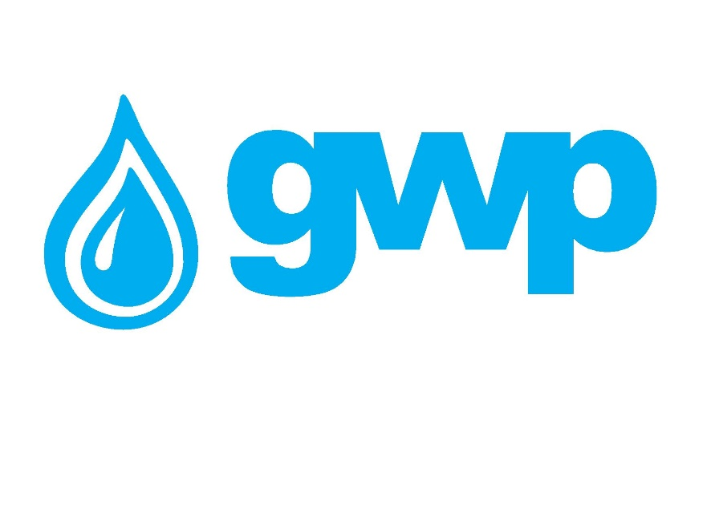

E-Tender Documentation for carbon steel valves

1.1 Title of procurement
Georgian Water and Power LLC announces electronic tender for the purchase of carbon steel and ductile iron valves

1.2 Description and quantity of goods

Detailed information is presented in Annex 1

Special requirements:

- All items must be designed and supposed to be used for drinking/potable water
- Valve endings must be strictly chosen according to Annex 1

1.3 Cost estimation
A Tender Participant shall provide cost estimation according to Annex 1

1.4 Deadline for delivery of goods / services / works
The Deadline for the goods delivery must be no later than 60 (Sixty) from the date of contract signature

1.5 Form and place for delivery of goods / service / works
Delivery Term shall be DAP, Tbilisi

1.6 Warranty Terms
The Tender Participant shall warrant that the Goods are made of best materials with first class workmanship, brand new and unused. The Tender Participant must provide minimum 24 (Twenty-four) months’ warranty period from the date of goods delivery.

1.7 Requirement of Experience
The Tender Participant shall have experience in supplying similar type of goods and submit relevant supporting documents: contract(s) and associated delivery-acceptance document(s) and/or reference number of the mentioned documents in Georgian procurement electronic system of the State Procurement Agency (e.g., NAT/CMR/SPA, etc.).

1.8 Terms of payment
Post Payment, Payment shall be made by Bank transfer, within the period of 30 (thirty) calendar days from the submission of delivery-acceptance documents.

Prepayment of 50% of the total contract amount will be allowed only on the basis of a bank guarantee.

1.9 Performance Guarantee

The Contractor shall present a performance guarantee in an amount of 5% of the contract value within 7 (seven) working days from the signature date of the Contract. The performance guarantee shall be issued by a bank licensed in Georgia or OECD member state (Organization of Economic Cooperation and Development). The term of validity of the guarantee shall be at least 30 calendar days longer than the term of the contract. In case the Contractor fails to present the guarantee within the agreed period of time, the Client shall be entitled to terminate the Contract.
1.10 Information to be uploaded/provided by bidders for electronic tender:
1. Price list according to paragraph 1.3;
2.Documents demonstrating experience of a Tender Participant in accordance within the paragraph 1.7;
3. Detailed Technical Specifications of the offered goods;
4.Information regarding Delivery, Warranty and Payment Terms, mentioned information shall be in consistency with the requirements of paragraphs 1.4, 1.6, 1.8;
4. Extract from the Registry of entrepreneurial and non-entrepreneurial (non-commercial) legal entities issued after the announcement date of the electronic tender.
Note:
1) All documents and/or information uploaded for the electronic tender by a bidder shall be signed by an authorized person (a letter of attorney shall be uploaded whenever required);
2) It is Preferable All documents and/or information prepared by a pretender to be verified by an authorized person using electronic signature or a stamp of the company.

1.11 Concluding a contract
1) A contract with the winner company will be signed in accordance with the terms of this tender.
2) Georgian Water and Power LLC reserves the right to sign a contract with one or more companies.

1.12 Other requirements
1.12.1 When submitting a bid, a bidder shall not be:
- in the process of filing for bankruptcy
- in the process of liquidation
- in conditions of suspended business activity.

1.12.2 Cost estimation shall be made in Georgian national currency (GEL). Prices must include all costs considered by this tender and taxes specified by the Georgian legislation.
1.12.3 Offer of the bidder shall be valid for 30 (thirty) calendar days from the date of its submission.
1.12.4 Georgian Water and Power LLC reserves the right to determine by itself the tender completion time, to change the tender terms under the notification timely given to the bidders, or to terminate the tender at any stage of its progress.
1.12.5 If the bidder is a foreign enterprise that is not registered in Georgia, bidder can send the bid via e-mail, which is indicated in the contact information of this tender documentation.
1.12.6 Also, if some technical problem will arise, during bid submission on tender site, the bidder can send a proposal on the e-mail specified in the tender documents. We would like to state that the proposal must be submitted by e-mail no later than 17:00 on December 20, 2022.
Georgian Water and Power LLC will identify the winner through the tender commission and inform all participating companies thereof. Georgian Water and Power LLC is not obliged to give a verbal or written explanation to any bidder on any decision made regarding to the tender.
Georgian Water and Power LLC reserves the right to verify any information received from the bidders as well as to obtain information about the company or its activities. If the information provided by a bidder is not true or false, the bidder will be disqualified.
Please, note that Georgian Water and Power LLC will not accept oral request for additional information. Only phone inquiries will be accepted.
Note: Any other information obtained in any other way will not be considered as official and does not generate any obligation from Georgian Water and Power LLC.

1.13 Information for participation in electronic tender:
1.13.1 Any question during the electronic tender process shall be made in writing and communicated through the Q&A platform of tenders.ge website;
1.13.2 To participate in the electronic tender, the company shall be registered on www.tenders.ge;
1.13.3 For instruction on participation in electronic tender through tenders.ge please refer to Annex 4.

Contact information:
Contact person: Vano Tsiklauri
Address: 10 Medea (Mzia) Jugeli str., 0179, Tbilisi
E-mail: vtsiklauri@gwp.ge
Tel.: +995 577 73 66 44

