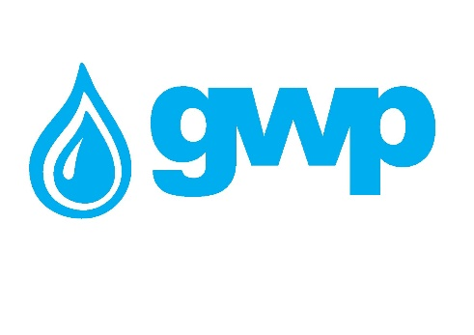

Electronic Tender Documentation
Procurement of Polyethylene e. Iron for welding roofs 20-1600 mm

1.1 Name of the procurement object
Georgian Water and Power Ltd (GWP, ID 203826002) announces an electronic tender for:
Procurement of Polyethylene e. Iron for welding roofs 20-1600 mm
1.2. Description of procurement object/quantity
Name: Portable ultrasonic cost meter with overhead magnetic sensors Polyethylene e. Iron for welding roofs 20-1600 mm
Quantity: see annex 3

Specification:
• voltage 220~230v;
• network frequency 50Hz;
• power not less than 3500 W;
• diameter to be welded 20 - 1600 mm;
• memory not less than 3700 reports;
• Class of protection against environmental factors: IP64
• Weight 15-25 kg;
• 1 year warranty
• The product must be new
• Must be mass produced
• The bidder must present a certificate of compliance with the quality standard of the products together with the tender proposal.

1.3 Estimation
The bidder must submit the estimates according to Annex N1 in Excel format.
Appendix N3 must necessarily indicate the goods manufacturing company, model/brand (if any), country of origin;
If the tender proposal (Annex N3) does not indicate the company producing the goods, the model/brand (if any), the country of origin, the proposal submitted by the bidder will not be considered.
1.4. Term of delivery of goods (contract).
The goods must be delivered within 14 (fourteen) working days after signing the contract.

1.5 Form and place of delivery of goods
Georgian Water and Power Ltd (GWP) Place of delivery:
Warehouse of "Georgian Water and Power" Ltd, Tskalsadenis N7
1.6 Payment terms
Payment will be made by consignment, cashless payment within 30 (thirty) calendar days after the delivery of the goods and the signing of the relevant act of acceptance and/or confirmation of the bill of lading.
1.7 Data to be uploaded / submitted by the bidder in the electronic tender:
1. Price table (according to Appendix N3);
2. Extract from the register of entrepreneurs and non-entrepreneurial (non-commercial) legal entities, which must be issued after the announcement of this electronic tender;

Note:
• All documents and/or information created by the bidder uploaded in the electronic tender must be signed by an authorized person (if necessary, a power of attorney must be uploaded);
• All documents and/or information created by the bidder should preferably be confirmed with an electronic signature of an authorized person or an electronic stamp of the company.

1.8 Signing a contract
Within the framework of this e-tender, a single contract will be concluded in accordance with the draft contract and the tender proposal attached to this tender.

1.9 Other requirements
1.9.1 At the time of submission of the proposal, the bidder should not be:
• in the process of bankruptcy;
• In the process of liquidation;
• In a state of temporary suspension of activities.
1.9.2 Presentation of prices is allowed only in the national currency of Georgia (GEL). Prices should include all costs and taxes (including VAT) provided by this tender.
1.9.3 The bid submitted by the bidder must be valid for 30 (thirty) calendar days from the date of receipt of bids.
1.9.4 The Procurer (Georgian Water and Power LLC (GWP, JSC 203826002) reserves the right to set the deadline for the tender, change the terms of the tender, notify the tender participants in a timely manner, or terminate the tender at any stage.
The Procurer (Georgian Water and Power Ltd (GWP, ID 203826002)) will identify the winning supplier to the Tender Commission and notify all participating companies of the decision. The Purchaser (Georgian Water and Power Ltd (GWP, ID 203826002)) is not obliged to provide the participating company with a verbal or written explanation of any decision regarding the competition.
The Purchaser (Georgian Water and Power LLC (GWP, ID 203826002)) reserves the right to verify any information received from the Bidders, as well as to obtain information about the Bidder Company or its activities. If it is proved that the information provided by the bidder is not true or falsified, the bidder will be disqualified.
Please note that the Purchaser (Georgian Water and Power Ltd (GWP, ID 203826002) will not receive any oral inquiries for additional information, except by telephone.
Note: Any other information obtained by other means will not be official and does not give rise to any liability on the part of the Purchaser (Georgian Water and Power LLC (GWP, ID 203826002)).

1.10 Information for e-tender participants
1.10.1 Any questions during the tender process must be in writing and the online Q&A mode of tenders.ge portal must be used;
1.10.2 To participate in the electronic tender, the company must be registered on the website www.tenders.ge
1.10.3 Instructions for participation in the electronic tender on tenders.ge can be found in the attached file
I got acquainted
/ Signature of the authorized person of the participating company /

Contact information:
Procurement representative
Contact person: Magda Lomtatidze
Address: Georgia, Tbilisi, Mtatsminda district, Medea (Mzia) Jugheli street, №10
E-mail Email: mlomtatidze@gwp.ge
Tel: +995 322 931111; 595 22 66 94

Contact person: Vakhtang Mchedlidze
Ms.: Georgia, Tbilisi, Mtatsminda district, Medea (Mzia) Jugheli Street, No. 10
e-mail Mail: vmchedlidze@gwp.ge
Tel.: +995 322 931111 (1143); 577999899

