**Georgian International Energy Corporation**

**SCADA system design development**

**Terms of Reference**

**for design preparation for automation of existing systems and SCADA system installation at Bzhuzha HPP**

(Preparation of design technical documentation)

**Tbilisi 2023**

Table fo Contents

Table fo Contents 2

Introduction 3

1. Basis for SCADA system installation 4

2. Purpose and designation of SCADA system 5

3. Precondition for SCADA system design at Bzhuzha HPP 8

4. Bzhuzha HPP technical data 9

4.1. Bzhuzha HPP technical description 9

4.2. List of systems to be designed in parallel with SCADA system 12

4.3. List of data to be displayed at SCADA system visualization screen 13

4.4. HPP internet connection 13

5. SCADA software and hardware requirements 14

5.1. Functionalities requirements 14

5.2. Reliability requirements 14

5.3. Operation conditions for SCADA system under design 15

5.4. Hardware settings and consistency requirements 15

5.5. IT and Software compatibility requirements 16

5.6. Transportation and storage requirements 16

6. Software and engineering technical documents requirements 17

Introduction

The purpose of the present terms of reference is design preparation for automation of existing systems and installation of SCADA system at Bzhuzha HPP owned by GIEC.

We aim to build SCADA extended system on the existing SCADA visualization system at Bzhuzha HPP. Support of visualization with State Electrosystem SCADA system shall be maintained.

Digital protection relay system, automation system of existing equipment and complete SCADA systems should have visualization and operation functions. They should be connected to the central SCADA system at the head office of the corporation. Also they should allow accessibility from the central office of the corporation with remote operation and monitoring functions.

This clause describes specific technical requirements, including issues of design preparation for automation of Bzhuzha HPP existing equipment, relay protection and SCADA system.

SCADA system design preparation requires introduction of automated operation systems and digital relay protection system at Bzhuzha HPP, design of which shall be prepared within the frames of SCADA system design. Thus, to prepare design for Bzhuzha HPP SCADA system, it’s required to make a design of the HPP digital relay protection systems and existing equipment automation system through rehabilitation or replacement of existing equipment, if necessary.

Information regarding Bzhuzha HPP existing equipment and the condition of the existing systems is described below in paragraph “HPP technical data.”

Nowadays there are quite a lot SCADA systems widely used in power generation. Bzhuzha HPP existing SCADA visualization system is built on the SIEMENS base. Therefore, it’s desirable to use SIEMENS software and supportive hardware while designing SCADA system. As to the design of the relay protection system, it’s desirable to use SCHNEIDER or SIEMENS hardware.

1. Basis for SCADA system installation

The basis for installation of SCADA system is to equip GIEC owned HPPs with modern operation and automation systems, incorporating them into a single system operated by the central SCADA system to be arranged at the headoffice of the corporation.

As of today Georgian Industial Group operates 8 HPPs. At this stage we are planning to introduce SCADA system at Bzhuzha HPP owned by GIEC enabling real time operation and control from the central office, design preparation of which is a part of this terms of reference.

SCADA system design shall comply with the requirements of resolution of GNERC on approval of Network Rules. Therefore, the Network Rules requirements shall be envisaged during Bzhuzha HPP automation, relay protection and SCADA system design preparation.

1. Purpose and designation of SCADA system

Designation of SCADA systems is a real time operation and monitoring of ongoing industrial-technological processes at the HPP. Also SCADA system shall have a visualization software for the screen of the operator enabling operation of technological and energy networks and visualization for dispatch service. SCADA visualization subsystem shall enable the following:

1. Visualization:

* Operating data: values of industrial process parametres
* Values of voltage, frequency and capacities at the busbars of the HPP hydro generation units.
* Condition of circuit breakers at busbars and at generator outlets
* Deviation from controlled values of the parameters (alarms), emergency signals.
* Archive data: settings: sms notifications regarding disturbance in generation process. User activities during process operation. Also system notifications from all subsystems towards automated operation systems and SCADA systems.

1. Operation:

* Possibility to turn on/off specific elements of the system, commutation possibility.
* Adjustment of unit settings. Changing settings of industrial technology process.
* Automated operation of units with the indicated settings.

Hardware and software interface of SCADA system shall be developed in accordance with the international standards to ensure step-by-step implementation and expansion of the system in terms of hardware development, enabling software functional interconnection with other computer systems.

The systems should work in two modes: development and execution modes.

Use of SCADA system under design, together with visualization subsystem and automated operation system should ensure:

1. Improved quality of electricity through improvement of the following:

* Providing information regarding HPP ongoing processes and condition of equipment to staff in a timely manner;
* Controlling activities of operators of technical equipment;
* Archiving settings of technical and technological processes during power generation process.

1. Increase safety of generation processes through possibility of limited access (not permanent presence) of staff at the area of technical equipment during their operation;

As a whole, SCADA system software should be based on open-standard system architecture to enable relocation of attachments among different servers. Software should be more flexible with possibility of integration with other softwares. All servers and other equipment located in server rooms shall be fixed on the stands.

**Main Server**

Main servers and data bases that facilitate operation of SCADA systems shall operate in real time (RTDB).

**Operational console**

Operational console shall consist of high capacity workstation, flat screen display with full graphic support (LED). Minimum 24” diagonal, with minimum dot resolution (1600X1200) VESTA standard.

All consoles should be equipped with necessary computing capacity, RAM, place at the hard disc, keyboard, display equipment and network equipment. A specific console for acoustic signal should be equipped with the sound card and speaker.

Graphical User Interface (GUI) operator’s console should be compliant to standards as follows: MSF/Motif, X-Windows or MS Windows.

System display and windows operation function, reference object and human-machine interface should be made available to display images at different levels of the system. It should be able to:

* Display diagram of network visualization and condition, as well as power flow and voltage stability limits.
* Image of a circuit single-line diagram about the power flows and voltages, showing the voltages at different levels in the areas of the circuit.
* With high/detailed resolution of substations, showing the condition of circuit breakers. The same time displaying in other windows details of substations located in remote areas.
* Districts and lists, tables, matrix and etc. that ensure recording and identification of activities, switches, reports and alarms.

**Time and Frequency Adjustment**

Design of the Corporation head office system should consider time and frequency equipment to ensure time coordination of entire system. Control time shall be communicated by the receivers using Global Navigation Systems (GPS). Time receiver shall be equipped with propagation delay compensator to ensure +/- 1 millisecond overall accuracy, as well as correction as per the local time. Time internal base shall ensure 1 millisecond or better accuracy.

**Historical Server Archive**

Historical server archive shall be based on full hot-standby redundancy concept and equiped with sufficient memory equipment, with filtration and verification functions that is crucial for effective storage, processing and retrieval of historical data. Servers shall be equipped with sufficient memory equipment that comply with the archive size requirements.

1. Precondition for SCADA system design at Bzhuzha HPP

To prepare design of SCADA system for Bzhuzha HPP, execution of technical re-equipment projects for several systems is necessary that should be cinsidered within the frames of this terms of reference. It’s necessary to install new automated operation systems at Bzhuzha HPP, as well as hydrounits frequency regulators with digital operation and monitoring system, digital protection relay and technological safety systems.

As already mentioned above, Bzhuzha HPP automated and SCADA systems design should be prepared within the frames of this terms of reference. Nowadays the only digital system at Bzhuzha HPP is an excitation systems which is compliant with SCADA systems and it’s possible to use it to build the given system. As to the other systems, they are built with the obsolete technologies and all of them need to be replaced and renovated.

Before starting SCADA system design preparation, after reading this terms of reference, it’s necessary to perform an on-site phisical study of the current condition of Bzhuzha HPP to facilitate accurate evaluation of volumes of the HPP automation and SCADA system design, number of equipment and volumes of installation works.

1. Bzhuzha HPP technical data
   1. Bzhuzha HPP technical description

Within the frames of this terms of reference we are submitting Bzhuzha HPP brief technical data. Tables 1, 2 and 3 show characteristics of the main technical equipment of Bzhuzha HPP.

Table 1.

|  |  |  |  |  |  |  |  |  |
| --- | --- | --- | --- | --- | --- | --- | --- | --- |
| Name of the HPP | Generator | Excitation system | Speed regulator | Disc-Lock | Protection relay system | Thermal control system | Digital operation and control system | Data acquisition and dispatch system |
| mgwt | SCADA |
| Bzhuzha HPP | 4,08 | Thyristor digital | Hydromechanical | Hydromechanical | Analogue | Analogue | NO | NO |
| 4,08 | Thyristor digital | Hydromechanical | Hydromechanical | Analogue | Analogue | NO | NO |
| 4,08 | Thyristor digital | Hydromechanical | Hydromechanical | Analogue | Analogue | NO | NO |

Table 2.



Table 3.



At present there is an excitation thyristor system at Bzhuzha HPP with digital operation support. This system should be integrated with automated operation and SCADA systems.

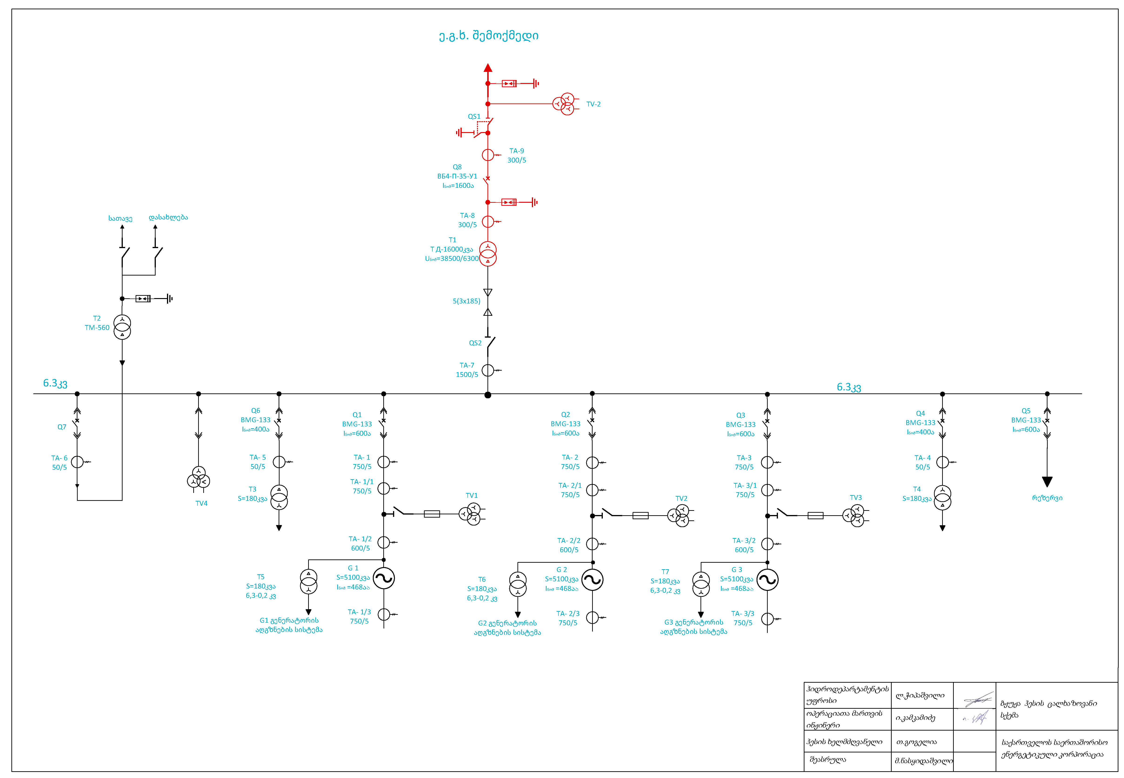

Illustration 1. Bzhuzha HPP single-line diagram

* 1. List of systems to be designed in parallel with SCADA system

To make a design of SCADA system for Bzhuzha HPP it’s necessary to prepare a design for rehabilitation or replacement of the following machinery and equipment. The design of the above-mentioned systems shall be prepared within the frames of this terms of reference and they should be compliant to the SCADA system.

**List of machinery and equipment to be designed inside the HPP:**

1. Generator control unit’s nozzles speed regulator for all three units.
2. Pipeline disc-lock for all three units
3. Designing generator speed automated system depending on the water level at the water tower.
4. Rehabilitation project of closed switchgear considering the single-line diagram
5. Designing transformer temperature and sulphur hexafluoride digital protection into the open switchgear, also digital operation system of circuit breakers and disconnectors.
6. Designing digital protection relay system
7. Designing electronic-digital system for electrical diagram

**Water tower:**

1. Design of electronic control system of existing emergency switchboard on the pipeline
2. Design of the grids automated cleaning equipment with automated operation system
3. Design of water flow and level measure equipment, integration of the existing one into the new design.

**At the headstation (river Bzhuzhi):**

1. Design of water flow and level measure equipment installation at water intake and at the entrance of the tunnel
2. Design of electronic control system of switchboards.
3. Design of the grids automated cleaning equipment with automated operation system
4. Design of sedimentation tanks automated washing system with electronic digital control.

**At the headstation (river Kalova):**

1. Design of water flow and level measure equipment installation at water intake.
2. Design of water flow meters installation project at the beginning of semi-closed channel and entrance of the water tower.
3. Design of switchboards electronic control system integration into SCADA system.
4. Design of the grids automated cleaning equipment with automated operation system.
5. Design of sedimentation tank automated washing system with electronic digital control.
   1. List of data to be displayed at SCADA system visualization screen

The following information shall be displayed at the visualization screen of generators and substation electric part, according to the HPP single-line diagram.

1. HPP single-line diagram virtual model, showing circuit breakers, disconnectors, generators, transformers, busbars and all the equipment stated on the electric diagram.
2. The mentioned panel should display real time data of generators and active, reactive and total power of the whole HPP. Generator voltage in phases, power voltage values at the outlets of the generator and the HPP. It should also show active, reactive and total power of transformer clamps.
3. Electric diagrams panel of specific generators, showing excitation system characteristics and temperature data of the generator.
4. Display real time data of protection relay and control signal condition. Display and control of warning and emergency signals.
5. Technology panel of the specific generator showing number of rotations, virtual model of automated regulator and all those parameters necessary to control technological cycle.
6. Panel of virtual model of the water tower and the both head stations, showing switchboards, sedimentation tanks, water levels and flows, also all those parameters necessary to control water preparation and provision during technological cycle of power generation.
7. Possibility to monitor all the above-mentioned technology signals, archive them according to the real time and copy or print in case of need.
   1. HPP internet connection

Bzhuzha HPP internet connection is secured through 4G modem installed at water tank. It ensures internet connection with HPP and head stations through media converters and fiber-optic circuit.

1. SCADA software and hardware requirements
   1. Functionalities requirements

SCADA functions and visualization functions should comprise the following:

* Showing operating and ongoing data. Transform generation process into graphic digital format (electric mnemo-diagram).
* Mark signals of process faults with color, blinking: line, text background or column. The list of faults should be displayed into a table format, showing specific faults transferred by digital protection equipment.

For operation, SCADA visualization subsystem should use input data from the following SCADA systems located at:

* Archives subsystem – to show archive data of generation process. To show notifications of the whole system and various types of notifications provided.
* Security systems – to show registered users.

Output data role in the visualization subsystem goes to:

* Image on display
* Change of current settings of generation process by the operator.

Subsystem configuration should be stored in xml format files.

Operating data update cycle should not exceed 1 second.

* 1. Reliability requirements

To ensure reliability of the system and prevent trespass, system should have multi-level protection.

* Overall SCADA level
* SCADA specific subsystem level
* At specific image element – with the function to restrict editing. Through changing the owner and on the right to edit, question and use accordingly.
* Error reason detection and sending appropriate notification

Visualization subsystem should meet the following reliability requirements:

* 24-hour uninterrupted regime, 365 days a year.
* Number of errors – no more than 1 error per 1000 operator.
  1. Operation conditions for SCADA system under design

To ensure reliable operation of SCADA system, computer rooms should meet the following conditions:

* Temperature 20÷25°C
* Ambient humidity 40÷60%

Qualification of staff of SCADA and automated operation systems should ensure effective operation of the system at any given mode and should meet the qualification requirements of HPP staff.

Staff, in charge of the power generation automated control system should be trained and tested in work safety issues in terms of software and hardware operation in generation.

A Specialist responsible for operation of software and hardware of power generation automated control system, should have relevant knowledge to:

* Execute operations on automated and related non-automated systems during power generation and generators’ operation.
* Make right decisions in case of emergency and other disfunctions of ordinary operation.

Should have experience that will enable him/her to perform all maintenance, installation and assembling operations accurately and in a timely manner.

Operative-technical staff should be trained in HPP operations and further tested during work process.

* 1. Hardware settings and consistency requirements

Hardware requirements for SCADA system operation are the following:

* X64 computing system. Processor of min cumulative clock frequency of 3-3,5 GHz
* RAM of 32 GB and more
* Video card of 8 or 16 GB
* Hard disc of 2X1000 GB
* Monitor of min 32”
* Keyboard
* Mouse

As to the automated operation systems and servers, they should enable receiving and sending data necessary for HPP operation and control, as well as technical conditions for storage of information. This equipment shall be located in separate closets with ventilation and heating to create necessary conditions for operation of electrical equipment through their lifetime.

* 1. IT and Software compatibility requirements

During operation SCADA system under design, uses input data from other SCADA subsystems.

* Settings subsystem – during process management, while receiving lists of settings of power generation and its attributes.
* Archives subsystem – display values of archive data of ongoing processes and display various types of notifications.
* Digital relays subsystem, through notifications of faults of operation processes.
* Security subsystem – to receive the list of registered users, while granting and verifying access rights.

Open SCADA system visualization subsystem should be developed on C++ language and compiled by GCC compiler. QT3 should be used as graphics library. These requirements of SCADA system are necessary for cross platform system used for SCADA systems and for SCADA system compatibility with dispatch service.

It’s desirable to keep configurated data of generation process in xml format files, as this format is a favorable mean for storing site text data.

* 1. Transportation and storage requirements

Data might be stored on a physical media as well as on internet resources.

In case of storing data on a physical media, the requirements are the following: it should be dry, protected from direct sunlight and electromagnetic fields. Storage duration shall be defined according to the type of the physical media. Transportation of the physical media may be performed with any method that excludes mechanical, thermal and electromagnetic impact.

Data stored at the internet resources might be copied with any method with the aim to further store them in a physical media.

1. Software and engineering technical documents requirements

Technical documentation of automated operation and SCADA systems and equipment shall include:

1. Terms of reference
2. System technical description(passport)
3. Complete technical documentation of installation diagrams.
4. Complete technical documentation, drawings and installation documents of electrical and mechanical equipment
5. Full specifications of the equipment and node specifications
6. Draft project including:

* Specifications
* Software description
* Software text
* Manual for developer
* Manual for engineers on automated operation and SCADA systems.