Georgian International Energy Corporation
DETAILED DESIGN STUDY SERVICES FOR

”1.9 MW GARDABANI HPP”
REQUEST FOR PROPOSALS

July 2023

- BACKGROUND / INTRODUCTION
Offerors are invited under this Request for Proposals (RFP) from suitably experienced companies (the Bidders) for a fixed price bid in order to execute Detailed design study Services for 1.9 MW Hydro Power plant on existing channel of thermal power plants (TPPs) located in Gardabani, Georgia.
As of today, the water supply system of the thermal power plants is as follows:
The technical water is supplied to the thermal power plant through two open channels from the weir, which is located on Mtkvari River: the main channel of the Gardabani irrigation system and the diversion channel for the water supply of the Rustavi industrial points. Both of these channels merge and water is supplied directly to the De-sander and WATER INTAKE of the TPPs.
From the water intake, technical water for cooling system is supplied to blocks No1-4 with two concrete penstock. The used water is discharged from the condensers in two main pipes and then connects two reinforced channels, which is located outside the blocks No1-4 near the block No9.
As can be seen from the analysis of the existing data, in case of stopping the thermal power plant (mostly in non-working regime), it is possible to use 20-25 m3/s of water discharge for the HPP (the size of the HPP reporting water intake should be determined at the detailed design development stage). At this stage, the value of water discharge is 23.8 m3/s. The HPP should be located in front of the shaft (9th block area), where there is a free space for arranging the building.
According to the pre-feasibility layout and in order to carry water from the settling pond to the Powerhouse (305 masl-293 masl) the existing double line concrete penstock should extend with new 400 m penstock. As mentioned above Downstream concrete penstocks there are existing underground pipelines that were designed to supply technical water to TPP units and future use of these underground pipelines in current project shall be studied and reported under present contract.

The powerhouse shall be located approximate at an elevation of 293 above sea level. The usable gross head between the water intake elevation and turbine jet elevation of 293 m above sea level shall be around 12 m with a net head of close to 10 m. The installed turbine capacity for the given design discharge is estimated to be around 1.9 MW.

Pre-feasibility documents can be found attached to this RfP

- PROJECT GOALS AND SCOPE OF SERVICE

In order to provide the best layout solution of new HPP and find acceptable water discharge, selected Company should study and analyze the existing technical water supply scheme of TPPs and water consumption of other users. Selected company should prepare detailed design report according to tasks shown in Terms of Reference document.
Terms of Reference (ToR) can be found attached to this RfP

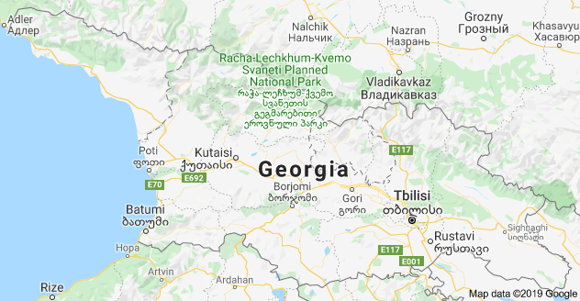
- PROJECT LOCATION
Site location

HPP location near TPPs
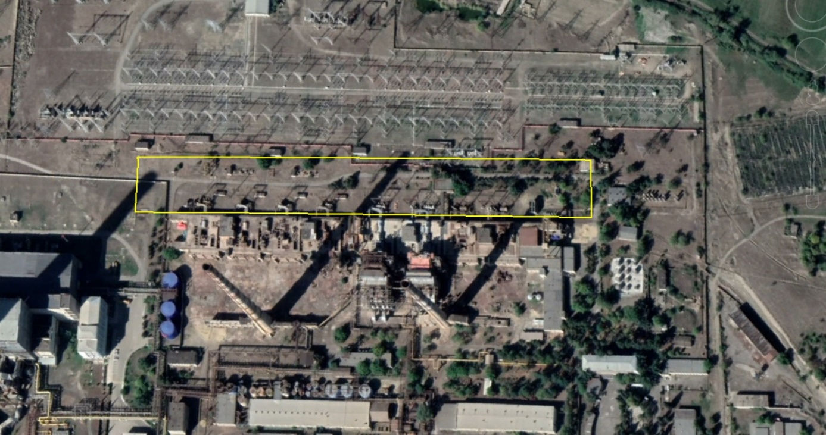

- DISCLAIMER

The information presented in this RFP is furnished solely for the purpose of assisting the Bidder in making its own evaluation of the Proposal and does not purport to be all inclusive or to contain all the information that the prospective Bidder may require.

The prospective Bidder should make its own investigations, projections and conclusions and consult its own advisors to verify independently the information contained in this RFP, and should obtain any additional information that it may require, prior to submitting a Bid. Neither Owner, nor any of their advisors makes any representation or warranty as to the accuracy or completeness of this RFP nor shall they have any liability for any losses or damages (including without limitation consequential loss or damage) whatsoever resulting from the use of or reliance on any representations (express or implied) or other information contained in, or omissions from this RFP.

- COST of PREPARING PROPOSAL

Regardless of the outcome of the evaluation process, all Bidders shall bear all costs and expenses associated with the preparation and submission of their proposals as well as their costs of negotiating & executing the Agreement.

- LANGUAGE of PROPOSAL

The Proposal and all related correspondence and documents shall be written in Georgian language. Supporting documents and printed literature furnished by the Bidder with the proposal should also be in Georgian.

- SUBMISSION DETAILS

Proposal should include following information:

- Total cost with price break down
- Schedule of submission of design report by each tasks
- Reference list of similar project of last 5 years

All Bidders shall declare list of necessary data that is required from the Owner in order to complete the detailed design Report.

- TIME AND PLACE of SUBMISSION OF PROPOSAL

Bidders are requested to submit electronic versions of their proposal by paper copy in a sealed envelope with the description “1.9 MW Gardabani HPP” and name of a Bidder company (e-mail version is also allowed, but please notify about that request in advance) no later than 31st of August 2023 17:00 Tbilisi Time to Georgian International Energy Corporation (GIEC).

Delivery details are:

Company | Georgian International Energy Corporation (GIEC)
Name | Irina Jelia  Head of Centralized Purchasing Department
E-mail | ijelia@gig.ge
Phone | +995 599 19 40 10
Address | Georgian International Energy Corporation GIG PLAZA  18, Gazapkhuli str. 0177 Tbilisi, Georgia

The proposed bid timetable is set out below:

Submission of Proposal: 31st of August 2023
Proposal evaluation process: 8th of September 2023
Clarifications & Contract Review Meeting: 22nd of September 2023
Signing Contract: 29th of September 2023
Submission of First Draft detailed design 27th of October 2023
Submission of final detailed design report 27th of November 2023

- EVALUATION CRITERIA

Evaluation criterion is determined by the following sequence:

- Total cost
- Company reference
- Time-schedule

- STUDY AND DETAILED DESIGN REPORT

From the date of signing an agreement, Bidder shall immediately arrange a kick off meeting with Owner to determine the expectations of the Owner along with the collected commercial and technical data (inputs) and possible configurations with their assumed outputs. Base on this agreed and collected information Bidder will start to work on the activities according to Terms of reference (ToR).

Terms of reference documents can be found attached to this RfP

- CURRENCY AND TERMS of PAYMENT

All Bidders are requested to hand over their bids in GEL (Georgian Lari) exclusive of all taxes.

The payment schedule will be as follows:

Advance payment 10% of the contract (against Advance Payment Bank Guarantee)
Approval of First detailed design Draft by the Owner 40% of the contract
Approval of Final detailed design report by the Owner 50% of the contract

- Enclosed documents to RfP

- Annex 1- Terms of Reference
- Annex 2- Prefeasibility study (GEO)
- Annex 3- Gardabani HPP single line diagram

