Project: Gardabani WWTP

FLOTTWEG DECANTER X5E-4/454 Xelletor with SP4.12

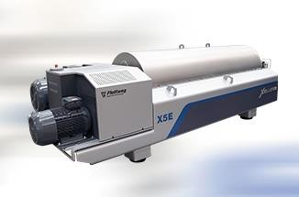

List of contents

List of contents 0
Technical description 3

Technical description

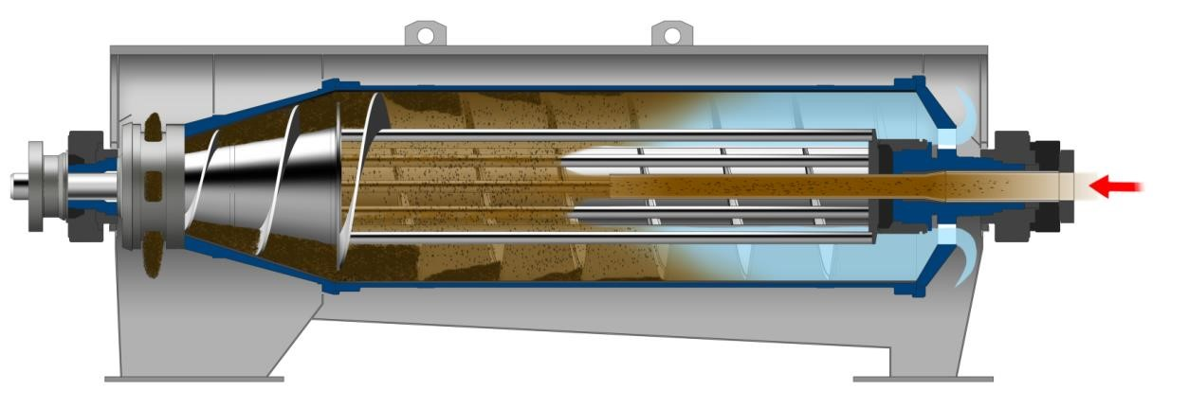

Separation Task:
Dewatering of primary sludge without digestion

Feed rate: 45 m³/h
Concentration inlet: 4%
Volatiles content: <68%
Dry solid after dewatering: 25%

Item 1 Dewatering decanter centrifuge

1 off FLOTTWEG decanter centrifuge X5E-4/454 Xelletor with SIMP-DRIVE® SP 4.12
For highest and most efficient possible dewatering of sludge.

Horizontal, cylindrical/conical solid bowl centrifuge in super-deep pond design with open scroll, for the continuous dewatering of sewage sludge.
The clarified liquid phase flows to the cylindrical end of the bowl. The dewatered solids are conveyed to the conical end of the bowl where they are discharged through ports via centrifugal force.

Technical data:
Bowl ID 570 mm
Diameter/length ratio 1 : 4 Cone angle 17.5°
Volume approx. 400 ltr.
Length/width/height approx. 4100 x 1550 x 1200 mm
Weight approx. 5400 kg
Bowl speed 3250 rpm (variable)
Max. acceleration factor ≥ 3340 x g
Differential speed | 0.5 - 10 rpm (variable)
Nom. scroll torque | 13000 Nm
Scroll design | Flottweg Xelletor  Lattice structure based open super-deep pond scroll design.  Flottweg Xelletor is the latest state of the art design in decanter scroll engineering. The scroll design merges the infeed chamber and pond surface, thus those parts form one unity. Thereby feed flow will be gently applied directly on the pond surface which leads to lower energy and polymer consumption

Recuvane® System

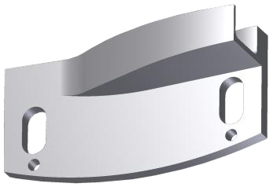
Thanks to the special construction of the RECUVANE® system the centrate can be discharged in a specific way allowing to recover kinetic energy. This energy is utilized to support the main drive. This can reduce the consumed power for the main drive motor by 10 to 20% depending on the pond depth and the suspension.

Materials
Product wetted | Cast duplex stainless steel 1.4463
supporting bowl parts: | with improved grade (equal to SAF 2205)
Scroll: | Cast stainless steel
 | 1.4408 and 1.4571 / 1.4404
 | (equal to CF-8M and 316 Ti / 316 L )
Other product wetted | stainless steel 1.4571 / 1.4404 or similar
component parts: | (equal to 316 Ti / 316 L )
Belt guard: | chrome steel, powder-coated
Other, not product wetted component parts: | carbon steel, painted
Drive system | Flottweg SIMP-DRIVE®
Bowl drive | Electric motor with V-belt drive.  Initial and operating speed settings via frequency inverter (Inverter not included in this item – please see item Control panel, if it is part of the offer).

Scroll drive  Wear Protection | Co-rotating, multi-stage planetary gear with electric motor and V-belt drive. A special coupling step within the gear enables entirely independent operation of the scroll drive from the bowl drive. The gear is easily accessible, and is mounted away from the bearing blocks and the process area. Differential speed and overload cut-out are electronically controlled by scroll torque feedback via an analogue signal from the frequency inverter (Inverter and control not included in this item – please see item Control panel, if it is part of the offer).
Scroll flight: | The leading edges of the scroll flight are protected with heat applied tungsten carbide spray
Bowl inside: | Tack-welded stainless steel strips in longitudinal direction
Bowl outside: | Tungsten carbide stripes
Solids discharge: | Ports are protected with hard metal wear bushings
Solids housing: | Protected with PU-liner
Feed area: | Wear reduced acceleration zone due to plunged lattice structure.

All wear bushings, hard metal wear segments, and wear liners in the solids housing are replaceable on site.

Lubrication

Automatic central grease lubrication system
The automatic central grease lubrication system supplies grease to both rotor main bearings via a progressive distributor. The lubricant supply is monitored by a sensor on the progressive distributor. The lubricant quantity will be determined by the duration of working intervals. The supply bin has a capacity of 2 kg and is equipped with a level sensor.

The scroll bearings are sealed-for-life.

Housing
Horizontally segmented housing
Cover sealed with a shaped flexible gasket

Sealing system
Both shaft ends of the rotor are sealed with labyrinth seals.
Scroll bearings are provided with slide ring seals.
Static seals: NBR

Sound insulation
The centrifuge is provided with sound insulation.
The rotor cover is double-walled and filled.

Painting
in accordance with Flottweg specification "Surface protection for Flottweg Decanters" colour RAL 5007 – brilliant blue colour RAL 7011 – iron grey
colour RAL 9006 – white aluminium

Covers
Drive belt guard is designed in accordance with EN guidelines.

Rotor base
Welded carbon steel design with rubber isolators mounted underneath the rotor base to dampen vibration induced movement.

Instrumentation
Differential and bowl speed
Main bearing temperature
Vibration

1 off Electrical drive motor for bowl
Design: in accordance with European Guidelines
IEC 60034
Rated output: 45 kW
Voltage/frequency: 400 V / 50 Hz
Speed: 1500 min-1
Enclosure: IP 55
Temperature protection: 3 PTC-thermistor sensors
Starting: frequency converter
(not included in this item)

1 off Electrical drive motor for scroll
Design: in accordance with European Guidelines
IEC 60034
Rated output: 15 kW
Voltage/frequency: 400 V / 50 Hz
Speed: 1500 min-1
Enclosure: IP 55
Temperature protection: 3 PTC-thermistor sensors
Starting: frequency converter
(not included in this item)

Tools
Standard tool in tool box for regular service and operation works. Standard mounting/dismantling device (bearing puller)

Lubrication material
Lubrication material for first replacement filling of the offered unit.

Item 2 Control Panel

1 off Module control cabinet

a. Basic configuration

Electrical control cabinet
Dimensions (WxHxD): 1200 x 1800 x 500 mm
Base height 100mm

Housing: Painted carbon steel RAL 7035
Operating voltage: 400 V / 50 Hz
Control voltage: 24 VDC / 230 VAC
Power feed: TN-C (L1, L2, L3, PE )
Cable entry: from below
Protection class: IP54

Building and testing regulations
Electrical equipment: DIN EN 60204-1
Low voltage directive: 2014/35/EU
Electromagn. compatibility directive: 2014/30/EU

List of components
Control cabinet housing: ELDON
Control: ET 200SP CPU 1510-F
(Programmcode Siemens TIA)
IO-System: SIEMENS ET200SP
Contactors: EATON
Emergency stop module: PILZ

Other electrical control cabinet components
Indicator lamps: "control voltage ON" / "fault indication active"
Overspeed monitoring (safety function)
Vibration monitoring (safety function)
Spare connection (230 VAC) for signal horn or flash light
Control differential speed

b. Main components
Frequency converter type: ABB ACS 580

Drives
1x Decanter Bowl-Drive 45 kW
1x Decanter SIMP-Drive 15 kW
1x Solids diverter gate (elektr. mit "AUMA"-Antrieb) 0,4 kW

Machine equipment
1x Autom. grease lubrication (Decanter) 0,75 kW
1x SIMP-Drive air cooled
1x Measurement Decanter (Speed monitoring, vibration)
1x Bearing temp. Decanter

Plant equipment

1x motor-driven valve Feed 24 V
1x motor-driven valve Solids Diverter 24 V

c. Signal exchange

Type: Dry contact
Output: Common alarm signal
Release product feed
Request solids output
4 programmable contacts
Input: Discharge OK
External start
Product feed operation Fault polymer station Fault flocculant min. Release centrate
1 programmable contacts

d. Control cabinet ventilation
To properly cool the control cabinet a filtered fan is installed in
the door. This blows surrounding air directly into the control cabinet. An appropriately-sized outtake filter is provided to return the heated air to the surrounding environment.

Temperature range required: 5 - 30 °C

For other temperature ranges or special environmental conditions (SO4 or H2S pollution, salty atmosphere) a control cabinet ventilation is not allowed.

e. Remote Access (eWON COSY)
Installation of a Hardware Remote Access. Access to network only with permission by customer. An unauthorized access by Flottweg or a third party is not possible. The Remote Access can be disconnected at any time by an electrical contact (actuated by the Touch Panel).
Access mode: WLAN

- Operator panel Touch Panel Line F 12"
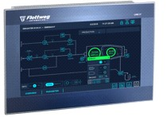
Display: 12'' wide screen (16:9)
Display surface: plastics front
Protection class: IP65

Surrounding conditions:
Temperature: 0°C - 40°C
UV-consistent: no
ATEX Area 1 / 2: no
Extended vibrational resistance: no

- Connection to a BUS system Available BUS connection: Profibus
Communication type: 64 Byte read and 64 Byte write

The following signals will be provided as read data:
Analog messages (REAL-data): Bowl speed
Differential speed
Scroll torque
Power consumption bowl
Bearing temperature
Number of revolutions
Vibration
Emptying times
Energy consumption
Bit messages (BOOL-data): Relevant alarms

The following signals will be provided as write data:
Analog messages (REAL-data): Bowl speed
Bit messages (BOOL-data): Start / Stop Decanter

Deviation from standard signal exchange only after consultation and at extra costs!

Additional documentation will be provided in the control panel Following documentation will be provided in a printed form.
Optionally this documentation can be provided electronically in .pdf format

1 x Wiring diagram and control panel layout
1 x Parts list of all devices
1 x Terminal layout
1 x Parameter lists for configured devices 1 x Functional description of operator panels if provided by Flottweg
1 x Operating manual
1 x Cable list (as necessary)

Appendix: General information about the offered cabinet

Environmental requirements (control cabinet):
Temperature: Depends upon cabinet cooling
No direct sunlight
Installation: Indoor
Limits according to EN 60721-3-3 class 3C2 (chemically-active):
SO2 Sulphur dioxide: < 0,37 cm³/ m³ (ppm)
H2S Hydrogen sulfide: < 0,36 cm³/ m³ (ppm)
NH3 Ammonia: < 4,2 cm³/ m³ (ppm)
NOx Nitrogen oxides: < 0,52 cm³/ m³ (ppm)

Limits according to EN 60721-3-3 class 3K3 (climatic):
Low relative humidity: 0,05
High relative humidity: 0,85
Low absolute humidity: 1 g/m³
High absolute humidity: 25 g/m³
Low barometric pressure: 70 kPa
High barometric pressure: 106 kPa

Limits according to EN 60721-3-3 class 3M1 (mechanical):
Displacement: 0.3 mm (from 2 to 9 Hz)
Acceleration: 1 m/s² (bei 9 bis 200 Hz)

Notes regarding electromagnetic compatibility (EMC):
The equipment is qualified for use in an industrial environment according to EN 61800-3 category C 3.2 CE. It is not intended for use in a public low-voltage network that also supplies residential areas. residential areas.
High-frequency interference is to be expected if it is used in such a network. Additional interference suppression measures may be required.

Requirements for the power supply:
Power quality according to DIN EN 61000-2-4
Overvoltage resistance according to DIN VDE0100 Part 443A (Cat. II)

Terminal connections / exemptions:
The main power feed to the control cabinet and the connections to the terminals are not included in this offer. Verification and acceptance of the electrical installation at the customer site will be according to the local regulations and are the responsibility of the customer.

Specific requirements, such as remote connection, customer-requested devices, stainless steel or fiberglass housing, different paint colors, conductor colors and customer review of design, can also be taken into account; please contact us for further technical and commercial considerations.

Item 3 Flexible connectors

1 off Flexible connectors for
- Sludge feed piping
- Centrate discharge piping
Condensate drain
Item 5 | Packing, freight and insurance
 | CIP Gardabani – INCOTERMS 2020, ICC.
Item 7 | Solids diverter gate
1 off | Solids diverter 8307.1
 | Actuator drive AUMA-Norm SA07.6, 0,4kW (400V/50Hz)
during flushing procedure and start or slowdown of the centrifuge, liquid may flow over on solids discharge. To avoid recontamination of dry solids, we recommend the use of our solids diverter.

For further information please see
