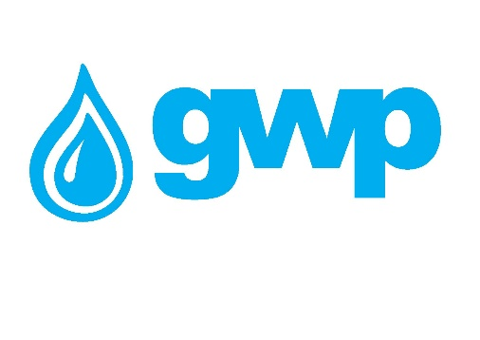

Electronic Tender Documentation
Generator Brake System Rehabilitation

Electronic tender documentation
Georgian Water and Power Ltd (GWP, ID 203826002) announces a tender for the following services:
Generator Brake System Rehabilitation

Technical Assignment is presented as Annex 1.

Notes:
• The aim of the competition is to select a qualified contractor who will provide the service according to the requirements TOR.
• It is necessary to inspect the brake system of the Zhinvali HPP generator on site.
• There are no complete detailed drawings on these works.

Requirements:
- The bidder must submit an estimation detailing the names of the works that will be performed and materials that will be used
- Submission of complete report of the work performed and relevant detailed drawings.
- Testing in accordance with European standards is mandatory.
- The bidder participating in the tender, must have work experience of similar nature, complexity and content provided by the tender (rehabilitation, modernization) during the last 5 (five) years.
- The bidder must submit copies of the documents proving the performance of the work of similar nature, complexity and content provided by the tender (copies of the contract, acceptance certificate and / or similar documents, from which it is possible to identify the content and values and nature ​​of the work).

Payment terms
Payment will be made by consignment, within 30 (thirty) calendar days from the provision of non-cash payment services and the signing of the relevant acceptance certificate and / or confirmation of the consignment note. In case of submitting a bank guarantee, it is possible to issue, a 20-25% advance payment

Data to be uploaded / submitted by the bidder in the electronic tender:
- The bidder must submit an estimation detailing the names of the works that will be performed and materials that will be used
- Extract from the Register of Entrepreneurs and Non-Entrepreneurial (Non-Commercial) Legal Entities, which must be issued after the announcement of this electronic tender.
- Consent to these tender conditions, for which a signed tender application must be submitted.
- The bidder must submit copies of the documents proving the similar nature, complexity and content of the work (copies of the contract, acceptance certificate and / or similar documents, from which it is possible to identify the content and values of the works).
- The signature of the authorized person and stamp of the company must confirm all documents and / or information created by the bidder.
- The contractor must sign the contractor's management plan

Signing a contract
• Contract draft upon request
• Contract performance guarantee - 5%.
• The warranty period of the work to be performed is 2 (two) years, from the date of signing the final acceptance-delivery act by the authorized persons of the buyer and the supplier.

Other requirement
At the time of submission of the proposal, the bidder must not be:
• In the process of bankruptcy;
• In the process of liquidation;
• In a state of temporary suspension of activities.

- Presentation of prices is allowed only in the national currency of Georgia (GEL). The prices should include all expenses and taxes provided by this tender (including VAT).
- The bid submitted by the bidder must be valid for 60 (sixty) calendar days from the date of receipt of bids.
- The Procurer (Georgian Water and Power Ltd (GWP, JSC 203826002) reserves the right to set the deadline for the tender, change the terms of the tender, notify the tender participants in a timely manner, or terminate the tender at any stage.
- The Procurer (Georgian Water and Power Ltd (GWP, JSC 203826002)) will identify the winning supplier to the Tender Commission and notify all participating companies of the decision. The Purchaser (Georgian Water and Power Ltd (GWP, JSC 203826002)) is not obliged to provide the participating company with a verbal or written explanation of any decision related to the competition.
- The Purchaser (Georgian Water and Power LLC (GWP, JSC 203826002)) reserves the right to verify any information received from bidders, as well as to obtain information about the bidding company or its activities. If it is confirmed that the information provided by the bidder is not true or falsified, the bidder will be disqualified.
- Please note that Purchaser (Georgian Water and Power Ltd (GWP, JSC 203826002)) will not accept any oral inquiries for additional information. Questions by phone are accepted as an exception.

Note: Any other information obtained by other means will not be official and does not give rise to any liability on the part of the Purchaser (Georgian Water and Power Ltd (GWP, JSC 203826002)).

Information for e-tender participants
- Any questions during the tender process must be in writing and the online Q&A mode of the tenders.ge portal must be used;
- To participate in the electronic tender, the company must be registered on the website www.tenders.ge
- Instructions for participation in the electronic tender on tenders.ge can be found in the attached file

Contact information:
Procurement representative

Contact person: Nino Koberidze
Address: Georgia, Tbilisi, Mtatsminda district, Medea (Mzia) Jugheli street, №10
Email Email: nkoberidze@gwp.ge
Tel: +995 322 931111; 555 68 93 98

Contact person: Irakli Khvadagadze
Address: Georgia, Tbilisi, Mtatsminda district, Medea (Mzia) Jugheli street, №10
Email Email: ikhvadagadze@gwp.ge
Tel: +995 322 931111 (1141);

The deadline for submission of the bids is January 23, 2024 12:00 Georgian Time.

