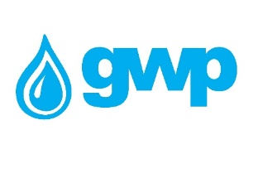

Technical assignment
1. The offerd pipes must have external and internal insulation
The proposed internal insulation should be one of the following but preferably Liquid applied epoxy;
- Cement mortar;
- Liquid applied epoxy;
- Fusion Bonded Epoxies;
- Polyurethane;
2. The supplier must consider hiring a quality control company (Bureau Veritas Georgia LLC or SGS) the service fee should be considered by the supplier in the unit price. The quality Control company must control/check and document the following items:
- Compliance of production with standards
- Compliance of raw materials with standards
- The quality of the material, insulation and its compliance with the standards established for drinking water
- Wall thickness
- The length of each pipe
- Welding testing using special equipment
- Pressure testing (compliance with requirements)
- The pressures of the proposed pipes must correspond to the required
- Compliance of the production, transportation and delivery schedule with the agreed conditions provided in the contract
- Preliminary verification of all necessary documentation before transportation
3. Adherence to the delivery schedule provided in the contract is a necessary condition - each violation of the schedule is determined by a one-time fine of 100,000 GEL (for each violation), and 10,000 GEL will be added to the fine for each overdue day.
4. MSF certificate is mandatory
5. The production should have the warranty; More warranty period will be beneficial.
8. 20% advance is given on the basis of bank guarantee (the advance can be increased if the quality control company confirms the rationality of the increase of the deposit, in accordance with the step-by-step instructions).
9. The supplier is obliged to sign the contract according to the draft contract proposed by GWP
10. Transportation EX-work or Delivery up to Rustavi or Khrami.

Quantity and specification are given in Annex N1

