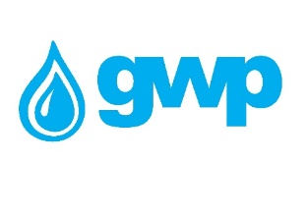

Technical assignment
1. The offerd pipes must have external and internal insulation
2. The proposed internal insulation should be one of the following but preferably Liquid applied epoxy;
- Cement mortar;
- Liquid applied epoxy;
- Fusion Bonded Epoxies;
- Polyurethane;
3. The supplier must consider hiring a quality control company (Bureau Veritas Georgia LLC or SGS) the service fee should be considered by the supplier in the unit price. The quality Control company must control/check and document the following items:
- Compliance of production with standards
- Compliance of raw materials with standards
- The quality of the material, insulation and its compliance with the standards established for drinking water
- Wall thickness
- The length of each pipe
- Welding testing using special equipment
- Pressure testing (compliance with requirements)
- The pressures of the proposed pipes must correspond to the required
- Compliance of the production, transportation and delivery schedule with the agreed conditions provided in the contract
- Preliminary verification of all necessary documentation before transportation
4. Adherence to the delivery schedule provided in the contract is a necessary condition - each violation of the schedule is determined by a one-time fine of 100,000 GEL (for each violation), and 10,000 GEL will be added to the fine for each overdue day.
5. MSF certificate is mandatory
6. MILL TEST CERTIFICATE
7. At least 40 years warranty should apply to the product
8. 20% advance is given on the basis of bank guarantee (the advance can be increased if the quality control company confirms the rationality of the increase of the deposit, in accordance with the step-by-step instructions).
9. A guarantee of 5 percent of the performance of the contract is required (a bank guarantee must be issued by a bank licensed by Georgia or a bank of a member country of the Organization for Economic Cooperation and Development ("OECD") and must be valid for at least 1 year after completion of works.
10. The supplier is obliged to sign the contract according to the draft contract proposed by GWP
11. Transportation EX-work or Tbilisi Tabakhmela or Tbilisi Natakhtari or Tbilisi Teleti area surrounding Shavnabada Monastery.
Quantity and specification are given in Annex N1

