1. Client Background
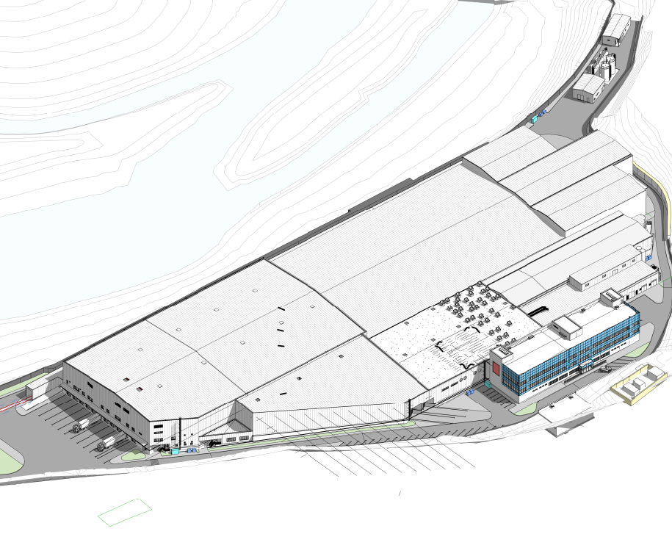  Terms of reference  MEP Works | Project Title  Borjomi Factory №2 reconstruction project. Phase №2 MEP works tender documentation package.  IDS Borjomi LTD

IDS Borjomi International JSC, implements reconstruction of natural mineral water processing factory, what includes Processing building, Energy Center, Office building, Warehouse and other functional facilities.
IDS is an international water company from Georgia, with leading market positions in Eastern Europe and Central Asia, actively developing new markets.
Company’s mission is to help people to achieve their life goals and lead a healthy lifestyle by wholesome properties of natural water, minerals and functional ingredients.
Company’s history dates back to 1890, when the Borjomi’s bottling plant was constructed and launched. Nowadays, Company sells over 1.8 bn liters of water across 40+ countries, engaging 4,500+ full-time professionals.
The following documentation defines Terms of Reference for Procurement and installation of Mechanical Systems.

2. Project Description
The project area is located in Borjomi municipality, near the village of Kvibisi, on a plot of 93,453 sq. m. (I/C. 64.22.04.012) Project combines various functional buildings under operation and another several buildings under construction.

Several buildings and structures have been dismantled in the project area, and the project itself involves the construction and reconstruction of the following buildings: Row Materials Warehouse, Water Treatment Plant, Energy Center, Warehouse of finished products, Administration Building, Railway Workers Building, Office Building, Ramp and platform, Wastewater Treatment Plant, fire pump station, and reservoir, Hazardous and Non-hazardous waste warehouses. The project also includes connecting engineering facilities on the plant territory and lighting the plant territory.

The buildings B1, B2 and T1 have already been built and are themselves the buildings of sandwich panels arranged on a metal frame on a concrete foundation. B3 are also built, it represents reinforced concrete buildings and contain complex technologies necessary for factory operation.

The rest of the buildings are designed, so that after their execution, the plant will receive the final appearance and be held technologically.
The main blocks of the building (B4 and B5) and several small blocks (B9, B10, B13, and T4) are concrete-based metal structures covered with a sub-construction of sandwich panels C or Z profiles and sandwiches.
The administrative building (B6) and several additional blocks (B7, B8, and T3) are reinforced concrete structures with a flat roof.

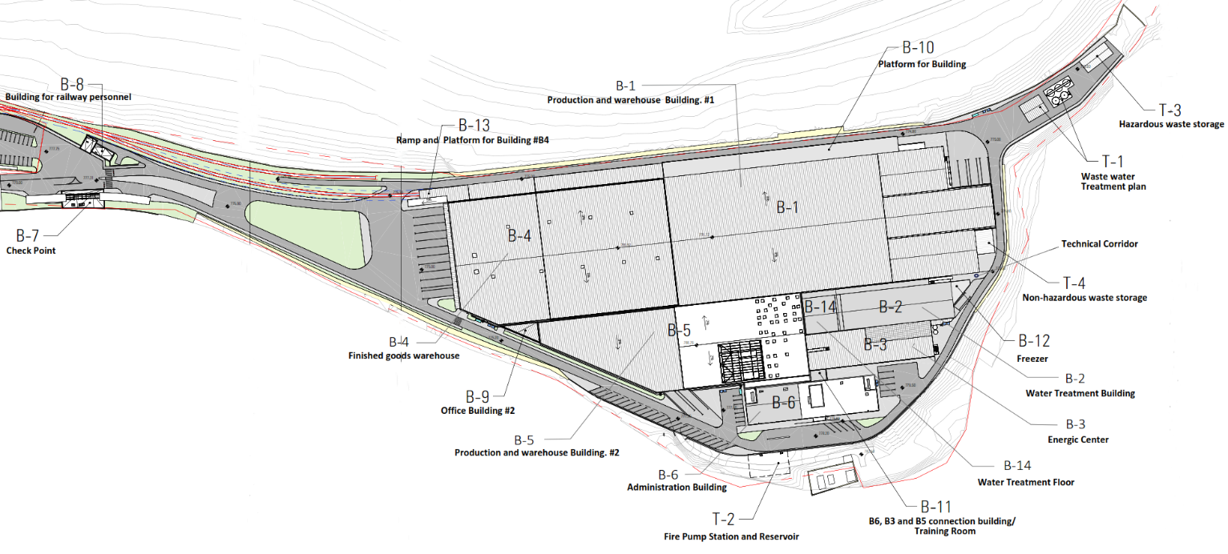

3. Procurement type:
Design-build lump sum contract for delivery, installation, testing and commissioning of Mechanical and Electrical Systems.

4. Design Drawings
Mechanical and Electrical systems design documentation (drawings and specifications) is attached.

Please, follow the link:
Note:
- Mechanical (HVAC, Plumbing, Firefighting) part of design work– Detailed design (CD) available.
Bidder shall review documentation for one business week and provide comments if they see any issues with the integrity and quality of the project; he shall take full responsibility for design work.

- Electricity & Low Voltage design work – Schematic design (“high level” assessment of volumes)
Bidder shall review documentation for two business weeks and provide comments and suggestions for design work improvement. Based on the information provided, the bidder has to deliver a commercial offer with a fixed price for all items mentioned in BOQ. The chosen Contractor shall elaborate on a detailed design (CD) in 1 month and agree with the client.

- Prices for materials, works, and labor costs presented in the commercial proposal must be fixed and not subject to any change.

5. Scope of Works and Deliverables
Selected contractor to be responsible for the provision of all labor, equipment, machinery and administration resources what is required for the timely execution of:
- Indoor Water Supply & disposal System;
- Indoor Firefighting System;
- Heating & Air Condition System;
- Humidification/Steam supply system;
- Ventilation System;
- Smoke exhaust system;
- Electrical system;
- Heat tracing;
- Low voltage system;
- BMS system;
Mentioned above utility systems are required for all buildings under construction, what combines the following:

Building | HVAC | Plumbing | Fire Fighting | Steam supply system | Electricity & Low Voltage | Smoke exhaust system | Heat tracing | BMS
B-1 |  |  |  | X |  | X | X
B-2 |  |  |  |  |  | X | X
B-3 |  |  |  | X
B-4 | X | X | X | X | X | X |  | X
B-5 | X | X | X | X | X | X |  | X
B-6 | X | X | X |  | X | X |  | X
B-7 | X | X | X |  | X |  |  | X
B-8 | X | X | X |  | X |  |  | X
B-10 | X | X | X |  | X |  |  | X
T-2 | X | X | X |  | X |  |  | X
Technical Corridor | X | X | X |  | X | X |  | X
Note: Humidification/Steam supply system generators are allocated in B-3 (energy center) steam generators’ room.
B-3 building itself do not require humidification system.

Buildings – B-1, B-2; B-3 and T-1 are already constructed and under operation (all works there to be confirmed and approved by the customer). Outdoor Utility works also not included (except the T-2 connection lines with all buildings and outdoor hydrant system).
The tasks to be covered and the expected results are fully functional mechanical and electrical systems, in accordance regulatory standards with expected lifecycle - 20 years.

Contractor is obliged to create and present for client approval:
- Method statement;
- Materials detailed data sheets;
- Site-Specific shop-drawings;
- As-Built drawings;
- Testing and commissioning protocol and report;
- Training provided to client’s service engineers;
- Equipment operational manuals;
- List of suppliers and contact details for the tools and spare parts;
- Equipment & Installation warranty documents.

Contractor’s responsibility includes but is not limited by:
General Requirements:

- Customs clearance, transportation and relevant permits, inspection of good on arrival, temporary storage and insurance of equipment and materials shall be the responsibility of the Contractor. Contractor shall undertake inspection of goods upon arrival at the project sites;
- The Contractor is to coordinate closely with client to implement hands-on training for the owners/operators of the system on its operation.
- Training manuals and materials must be provided in English (and local language as necessary) and include trouble-shooting manuals and manuals of specific parts and materials.
- All engineering equipment and liner installations should be properly labeled and coded and main single line diagrams to be attached at installation sites where required;
- Central equipment to be start-up under manufacturer supervision under local qualified personal trained certified by manufacturer;
- For all Firefighting installed systems shall be performed testing and commissioning and obtain from relevant Government authority’s approvals- certificates.
- Due to the fact that one Air Coold Chiller (Aermec) for the B-6 is already procured, second one to be procured from the same brand.
- All BoQ-s are just in additional information, which should be checked and confirmed by the bidder. In some extent (Technical Corridor, Smoke exhaust systems (B-1 and B-2, Earthing/Lighting-Protection (B-4, B-5 and B-6) and so on) bidder to make takeoff from the existing drawings and make its one BoQ).

Technical Requirements:

- The Contractor prepares a commissioning protocol, which is approved and signed by the Customer; in the case of Fire Fighting systems, it is approved and signed by the Client and relevant Government Authority Agencies.
- Contractor should foresee costs, related of material wastes, lifting equipment, supporting fixation & etc.
- All supporting and fixing details to be foreseen as the mechanically connected to the mainframe of the buildings metal structure (B-4 and B-5)

1 – Metal mainframe partition;
2 – Сlamp;
3 – Air duct /Pipe hanger;
4– Trunnion

- All prices to be given with consideration of technical waste and other expenditures accruing during manufacturing and installation process;
- All outdoor installed equipment to be manufactured for outdoor use with corresponding coverage and protection;
- Steam, Water & air system to be flushed, tested & balanced with presence of client or his representatives and with following report publishing;

Extent of work/ Care of the Building
- The work shall comprise all labor, including supervision and all materials necessary to make a complete installation and such test adjustments and commissioning as may be required by the Client. The term complete installation shall not only mean significant items of the plant and equipment covered by specifications, but all incidental sundry components necessary for complete execution and satisfactory performance of installation with all layout charges, whether or not those have been mentioned in detail in the tender document in connection with this contract.
- Minor building works are necessary for installing equipment foundation, making openings in walls or floors and restoring them to their original condition, finishing and necessary grouting, etc., as required.
- Maintenance (Routine and preventive) for two years from completion and handing over.
- The work is a turnkey project. Any item required for project completion, but left inadvertently shall be executed within the quoted rates.
- Care shall be taken by the contractor while handling and installing the various equipment and components to avoid damage to the building.
- He shall be responsible for repairing all damages and restoring them to their original finish at his cost.
He shall, during the execution of the work and upon completion (but not later than in a week period of time), remove all unwanted and waste materials arising from the installation from the site of work at his cost. All waste to be collected and stored in full accordance with HSE norms and regulations. No waste materials to be left behind the contractor, which will be the obstacle or problem for the other contractors conducting the works at the same area or building.

6. Compliance with Technical standards and Regulations.

All design and installation work to be in full accordance with applied Georgian regulatory requirements.

- All works shall be carried out following, but no limited by the relevant regulations.
Mechanical part:

SMACNA - Guidelines for Roof Mounted Outdoor Air-Conditioner Install;
HVAC Duct Construction Standards - Metal and Flexible, 4th Edition
HVAC Duct Systems Inspection Guide
HVAC Systems Commissioning Manual
HVAC Systems Testing, Adjusting & Balancing
System Air Leakage Test Standard

International Plumbing Code (IPC)
СП 1.03.02-2020 МОНТАЖ ВНУТРЕННИХ ИНЖЕНЕРНЫХ СИСТЕМ ЗДАНИЙ И СООРУЖЕНИЙ
СП 89.13330.2012 КОТЕЛЬНЫЕ УСТАНОВКИ
ВСН 25-09.67-85. Правила производства и приемки работ. Автоматические установки пожаротушения

NFPA – 13 Standard for the Installation of Sprinkler Systems
NFPA – 14 Standard for the Installation of Standpipe and Hose Systems
NFPA – 20 Standard for the Installation of Stationary Pumps for Fire Protection
NFPA – 25 Standard for the Inspection, Testing, and Maintenance of Water-Based Fire Protection Systems

Electrical Part:
ГОСТ Р 50571.15-97 ЭЛЕКТРОУСТАНОВКИ ЗДАНИЙ
ПУЭ. Правила устройства электроустановок. Издание 7
ГОСТ Р 56555-2015 Кабеле проводы и помещения

ГОСТ Р 59638-2021 Системы пожарной сигнализации
СП 134.13330.2012 «Системы электросвязи зданий и сооружений.
ГОСТ Р 51558-2008 Средства и системы охранные телевизионные. Классификация. Общие технические требования. Методы испытаний
NFPA 70 National Electrical Code
NFPA 72 National Fire Alarm and Signaling Code

- Nothing in this specification shall be construed to relieve the successful tenderer of his responsibility for manufacturing, and installing the equipment with all accessories by currently applicable local statutory regulations and safety codes.
- The successful tenderer shall arrange for compliance with statutory provisions of safety regulations and departmental requirements of local safety codes concerning labor employed on the work by the tenderer.

7.Guarantee

- All equipment and installations shall be guaranteed for minimum 24 months from the date of taking over the installation by the Client against unsatisfactory performance and/or breakdown due to defective design quality of material.
- The equipment or components, or any part thereof, so found defective during the guarantee period shall be forthwith repaired or replaced free of cost.
- There are following special requirements towards the main equipment grantees:

- Chillers shall be guaranteed for minimum 36 months from the date of taking over by Client;
- Boilers shall be guaranteed for minimum 36 months from the date of taking over by Client;
- AHU units shall be guaranteed for minimum 36 months from the date of taking over by Client;
- VRV/VRF main units shall be guaranteed for minimum 36 months from the date of taking over by Client;
- Steam Generators shell be guaranteed for minimum 36 months from the date of taking over by Client;
- Pumps shall be guaranteed for minimum 36 months from the date of taking over by Client;
- Heat exchanger shall be guaranteed for minimum 36
- DHW water tank shall be guaranteed for minimum 36

- Bidders must provide details of the terms of the warranty and an overview of the recommended service intervals to comply with the terms of the warranty and provide separate detailed proposals for service conditions for two years. The price offer is to be given simultaneously as the design-build contract offering.

Important note: Guarantee period will be counted from the date of taking over by Client

8. Terms of Payment

- Advance - 20% of the contract value.
- Remaining contract value will be paid monthly based on the IPC (Interim payment certificate) amount.
- Retention sum: The quality deposit is in the amount of 5% of the contract value. The deposit is returned upon expiration of the guarantee period provided for in the contract (24 month from the date of taking over by Client).
- From each IPC advance and retention sum will be proportionally deducted.
- Material on site value might be paid (only for main equipment), but not more then 50% of total value of equipment indicated in BoQ.

Important note: No works or material price will be paid for the work or material, which will not be agreed and approved by the customer or his representative prior any material will be procured and any work will be started;

9. Completion of period and important milestones:
The completion period of approx. 7 (seven)months (depending on the buildings) indicated in the tender documents is for planning, designing, supplying, installation, testing, commissioning, and handing over the whole system to the Client.

Approximate timeline for each building installation works:

Building/ Areas | Start Date | Finish Date
B-1 | May-24 | Dec-24
B-2 | May-24 | Dec-24
B-3 | May-24 | Dec-24
B-4 | Jul-24 | Dec-24
B-5 | Jul-24 | Jan-25
B-6 | Aug-24 | Feb-25
B-7 | Sep-24 | Dec-24
B-8 | Sep-24 | Dec-24
B-10 | Sep-24 | Dec-24
T-2 | May-24 | Oct-24
Technical Corridor between B-1 and B-2; | May-24 | Sep-24

Note: By the end of August 2024, 50% of the lighting installation works in building B-4 should be completed.

Important note: In already operational buildings (B-1, B-2 and B-3) construction works period and sequence will be agreed based on the windows given by the manufacturing facility management.

10. Financial and Legal Requirements

- Contractor has to deliver irrevocable and unconditional bank guarantee for advance payment, which should be equal to advance payment requested by the contractor (guarantee should be provided by the first class international or leading Georgian Bank). Guarantee should cover risks of failure to perform or undue performance by the contractor of all of its obligations until delivery of the goods, including but not limited to schedules of design, manufacturing and delivery, quality of goods and other obligations;
- Contractor has to deliver irrevocable and unconditional performance guarantee in amount of 10% of total contract value (guarantee should be provided by the first class international or leading Georgian Bank) covering risk of failure to perform or undue performance by the contractor of all of its obligations until the end of the contract;
- Bidder has to provide statement from local financial regulator stating that organization has no uncovered liabilities towards the Government;
- Contractor has to provide statement from local regulator/court showing that there is no open lawsuit against him, which may cause problems to contract in future;
- Contractor has to provide document from public registry showing ownership of the company participating into the tender;

11. Qualification requirements
Contractor should qualify following minimum criteria:
- Installation of MEP (all systems: mechanical, electrical and plumbing) with total price at list 10 million USD during last 3 years;
- Total turnover during the last 5 years not less than 15 million USD;
- Construction of at least 1 industrial building/buildings projects with total area at list 5 000 sq/m;
- Existing of Design Department into the potential contractor’s organization structure;
- Two Design project with minimum area of 3000 square meters with different functions (not residential)

